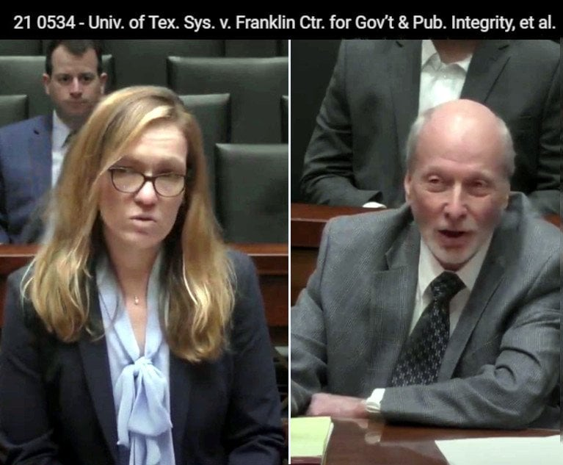Lanora Pettit for UT System (left) and Joseph Larsen for Franklin Center. Credit: Texas Supreme Court video archive.
NEWS

Will It Be Covered by Attorney-Client Privilege? Texas Supreme Court Weighs Revision
"If this court rules for the University of Texas, I guarantee you that every governmental body is going to start running their investigations through their counsel's office just to be able to withhold it from the public," Larsen said.
5 minute read
Public Records

What You Need to Know
- The Texas Supreme Court heard argument for and against creating a more narrow or a broader standard for attorney-client privilege.
- The case, University of Texas System v. Franklin Center, deals with attorney-client privilege for government entities in a Public Information Act context.
- Franklin Center warns a decision in UT System's favor would render the act nearly useless.
Texas Supreme Court justices debated on Wednesday the ramifications should they change what triggers the attorney-client privilege in the context of government entities and the Public Information Act.
During oral argument in University of Texas System v. Franklin Center for Government and Public Integrity, the justices looked at walking a tightrope between a decision so broad it could render the Public Information Act meaningless, or a decision so narrow it could adversely affect attorneys’ relationships with government entities.

Litigation Consultant?
The underlying case involves a years-long controversy within the University of Texas System over allegations of misconduct in the admissions process. After an internal investigation conducted through the university’s general counsel office was received with public skepticism, an outside consultant, Kroll Associates Inc., was hired to do an independent investigation.
The Kroll report was made public, but the Franklin Center for Government and Public Integrity, a government accountability-focused nonprofit news organization, sought hundreds of documents used for the report.
The UT System balked, claiming the requested documents were attorney-client privilege, and won in trial court, but the Third District Court of Appeals reversed, asserting that Kroll did not act as a litigation consultant. The UT System appealed.
Office of the Attorney General attorney Lanora Pettit, speaking for the university, said the Third District erred by combining an unduly narrow reading of the attorney-client privilege statute with an unduly broad understanding of common law waiver by publication.
The Third District’s opinion, Pettit said, would “effectively preclude a government lawyer from using an outside consultant investigator to look into the facts behind allegations of misconduct.”
Pettit claimed the university provided ample evidence to show Kroll had a dual role as investigator and legal consulting, adding the state rule “simply says to assist in the rendition of professional legal services—not primarily, not predominantly and certainly not solely, as the Third Court seemed to imply.”

Legal Services?
Joseph R. Larsen of Gregor Wynne Arney, arguing for Franklin Center, focused on the role given Kroll as investigator, insisting the firm was brought in to show the public a nonpartisan independent agent found no misconduct.
Justices Debra Lerhmann, Brett Busby and Evan Young kept coming back to how that task couldn’t possibly be a legal service.
“Isn’t that really the provision of legal services? Because the result of that, one way or the other, is either going to point to potential liability or not,” Lerhmann said.
“If wrongdoing is not revealed, then a lawyer’s job is pretty easy,” Busby said. “What’s your proposed test when it would or when it wouldn’t?”
Larsen argued Kroll’s role was limited to being a fact finder and it was up to the UT System general counsel to provide legal advice.
Young, unconvinced, said Kroll was acting as a substitute for the very thing the general counsel had done, “which per force is legal work.”
Larsen then pivoted to UT’s assistant general counsel affidavit affirming Kroll was providing legal service. This was the prima facie evidence in UT System’s favor that was relied upon in the lower courts. He challenged it as insufficient, a position that undercuts In re Dupont de Nemours & Co., a 2004 Texas Supreme Court case that allowed such evidence in a discovery context.
Larsen said that type of admission in the Public Information Act (PIA) context is very troubling.
“We need to overrule Dupont in order for you to win?” Young asked. “You’re saying that Rule 503 doesn’t apply in the same way in the PIA.”
“I think the way the court has interpreted the rule in Dupont, to require the prima facie case and then throw the burden to the other side is simply unworkable,” Larsen said. “The government should have a lesser attorney-client privilege because the attorney-client privilege in the context of the government-and-the-people is an impediment to limited government.”
“If this court rules for the University of Texas, I guarantee you that every governmental body is going to start running their investigations through their counsel’s office just to be able to withhold it from the public,” Larsen said.
Young asked Pettit what assurance might there be to prevent government entities from bringing a lawyer in every time they wanted to conceal information from the public.
“There is a very heavy responsibility in Texas that government entities act in good faith,” Pettit said, adding that should it be proven the attorney was not performing a service requiring legal knowledge and skill, that would be against the law.
“How is the challenger going to be able to prove that it wasn’t in good faith?” Busby asked.
Pettit noted that this is a Public Information Act case, which affords the ability for discovery.

